Discussion Minutes:

* Tobias will work on more stuff next week - been busy with setting up for HackRPI and trying to stay on top of the workload as well
  + Priority 1 is the Login CSS, Priority 2 is the Shopping List
* Alex had various health problems, nothing got done this week :(
  + Going to work on the stuff I said I would last meeting over the weekend and throughout next week
  + Next week I will have the star rating done, create something for lemon vs lemon juice
  + Star rating method:
    - On recipe table, adding another column that has some JSON (number of 1 star, number of 2 star, number of 3 star, number of 4 star, number of 5 star)
    - 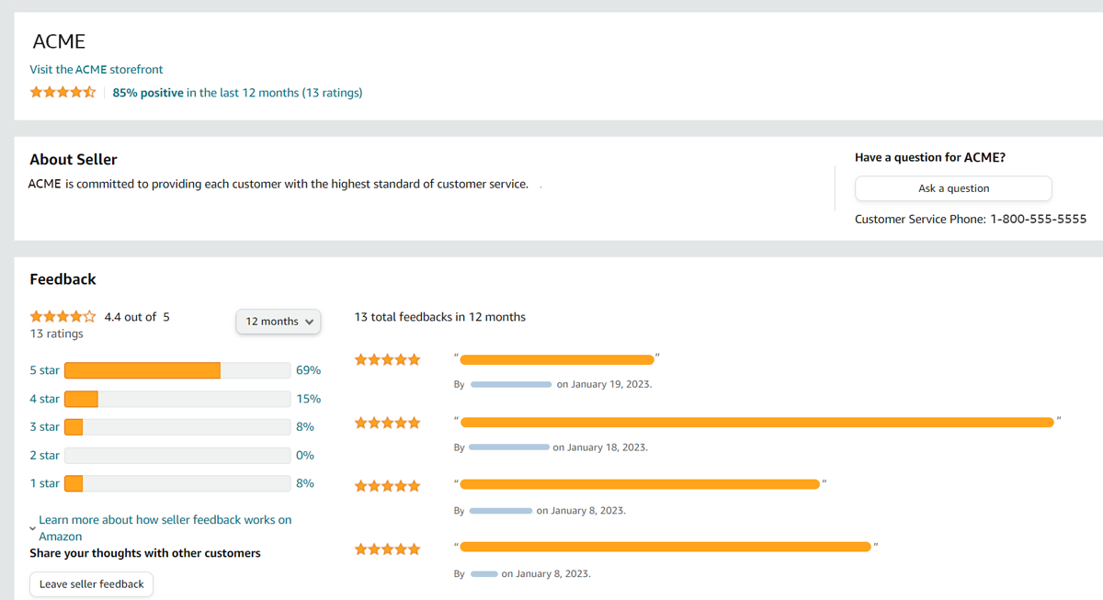
* Diego continuing work on home page, specifically pantry preview animations and dynamic loading from the database
  + Next task is to start finalizing the pantry and recipe generator pages (backend is basically done, just need to finish frontend)
  + Finish extra pages like about, contact, etc
  + Random number generation for recipe preview (generate random number and somehow tie that to a row number in the recipe DB, then maybe preview the next 4 from there
    - Pantry preview could work similarly, selecting random row and then displaying that and the next 4 items

Things we want completed by next week:

* Branding implementation in bootstrap (color scheme + logo) (Yiqi)
* Finish polishing the recipe generator backend based on the feedback (Alex)
* Add star ratings to the recipe table (Alex)
* Login page CSS (Tobias)

Remaining Task Items for Project: high priority, medium priority, low priority

* Login, signup
  + Login, signup CSS (Tobias)
* Home
  + Home page CSS (Diego)
  + Shopping list functionality (Tobias)
    - When you hit the checkmark to check an item off the list, it removes it from the list
* Backend
  + Integrating Display Backend from the work Alex did (Alanah)
  + Star rating (Alex)
  + Lemon vs lemon juice :( (Alex)
  + Ingredient exclusion filter (i.e. for dietary restrictions) (Alanah)
* Security
  + Error 404 pages (Alanah)
  + Session security upgrades (Alanah)
  + Phpmyadmin Password is within VM and not Folders (Alanah)
  + Phpmyadmin user with limited privileges (Alanah)
* Miscellaneous
  + Landing page CSS (Yiqi)
  + Branding implementation (color scheme + logo) (Yiqi)
  + Add your own recipe page (Yiqi)
* Frontend
  + Pantry page (Alanah)
  + Recipe generate (Alex)
  + Home/landing page (Diego)
  + Login page redesign (Tobias)
  + All CSS + Bootstrap being conducive to branding (Yiqi)
    - For consistent fonts and colors